Metrix Learning Registration Process

workforcesolutionspc.metrixlearning.com

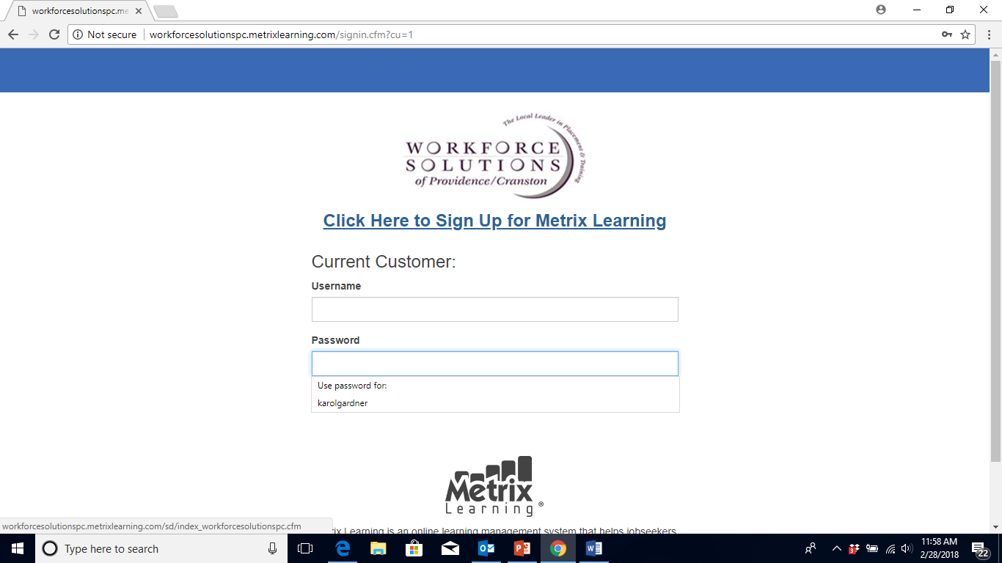

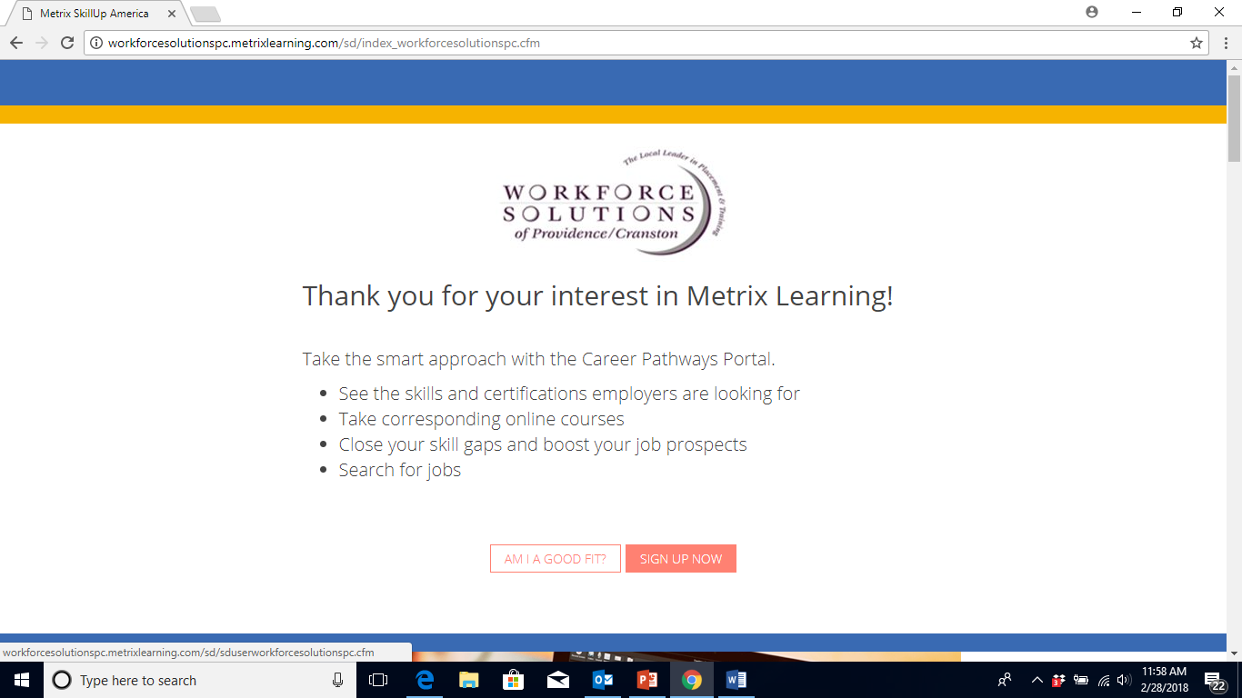

Complete all of the information.
*Please note: customers from any RI zip code may register

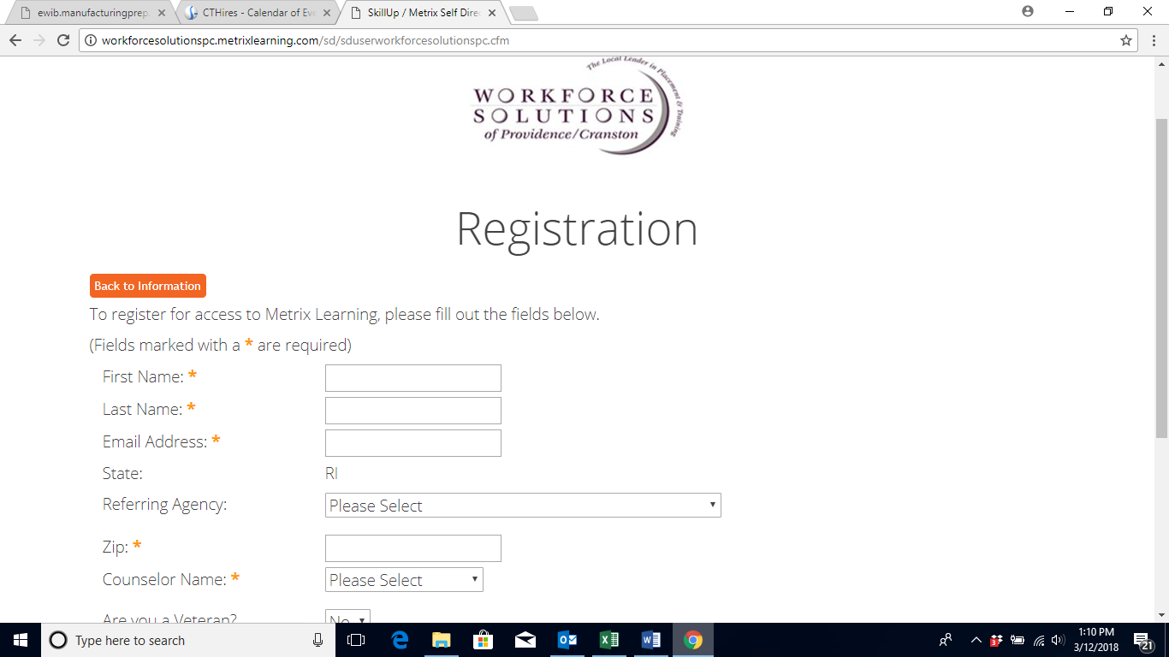

Referring Agency must be selected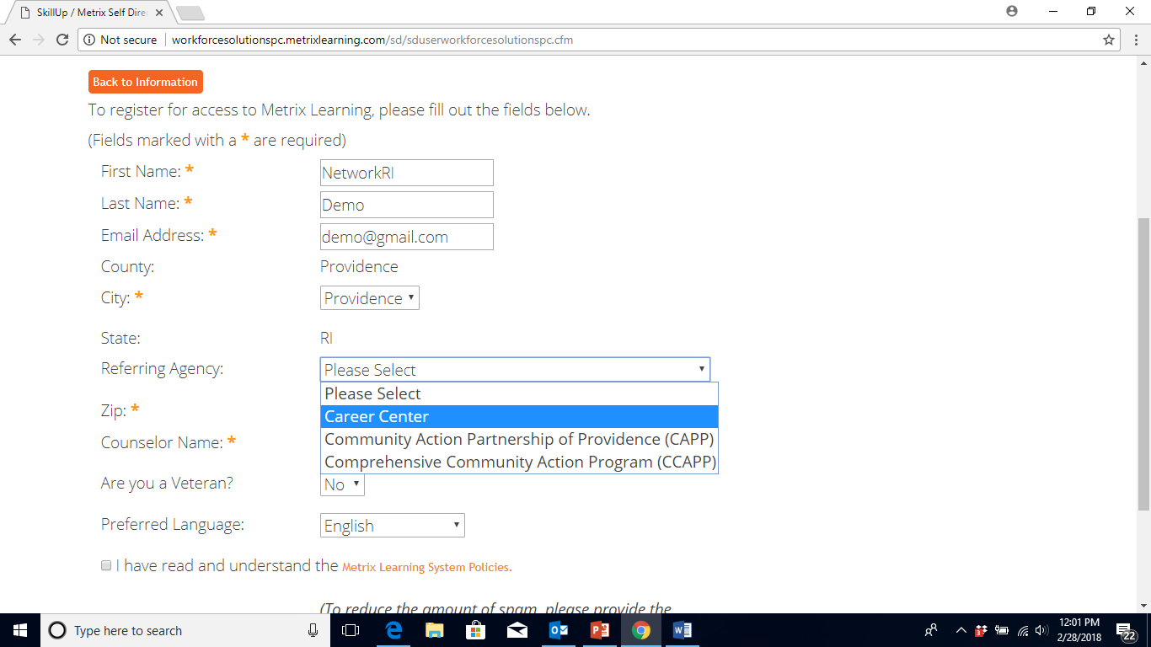

Counselor name should be selected for reporting purposes.
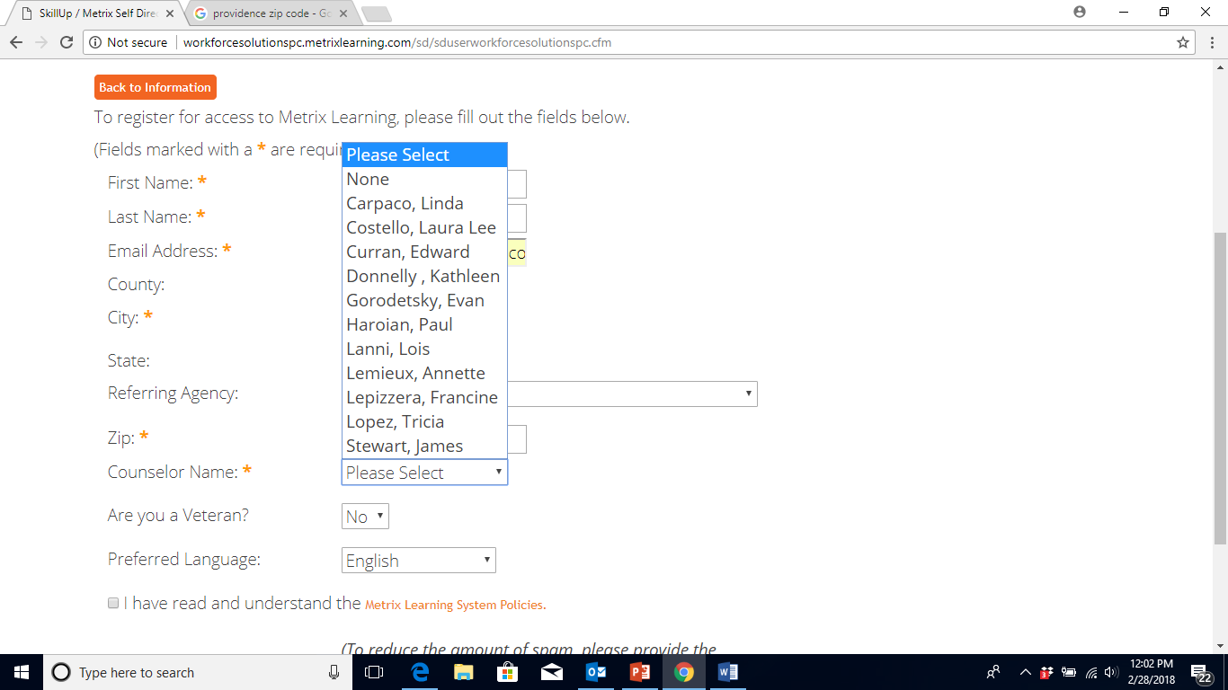
When all of the information is completed and the policies reviewed – click Register
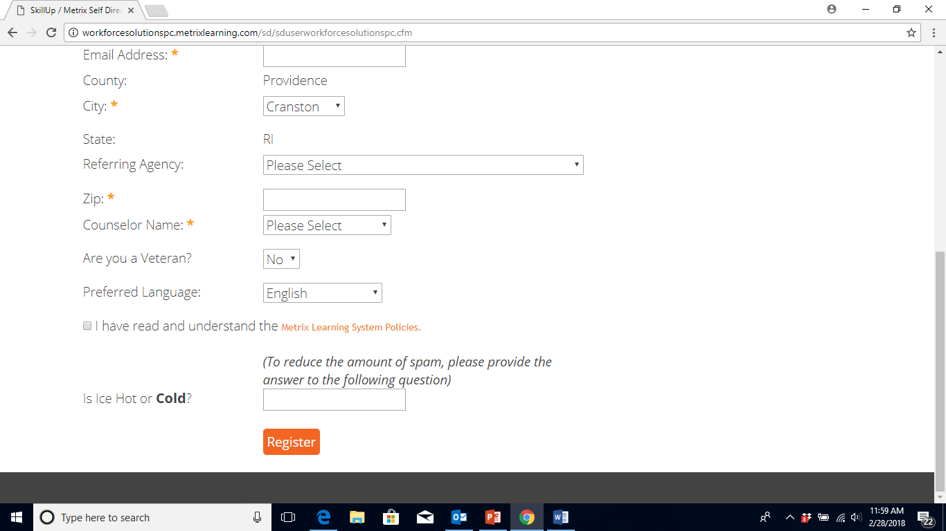

The customer will immediately be directed to Metrix Learning.
The “Getting Started’ tutorial will pop up.
Customers will also receive an email with their username and password.
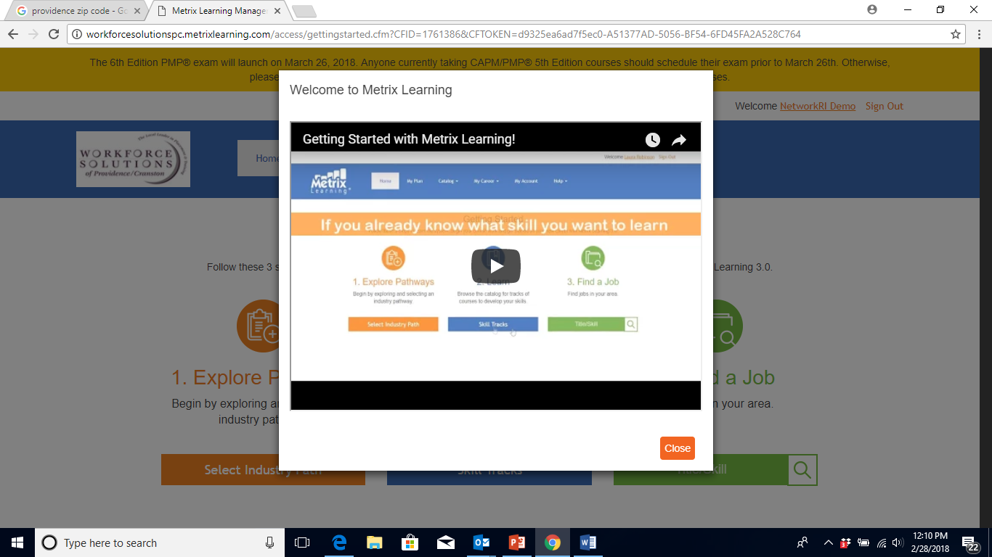

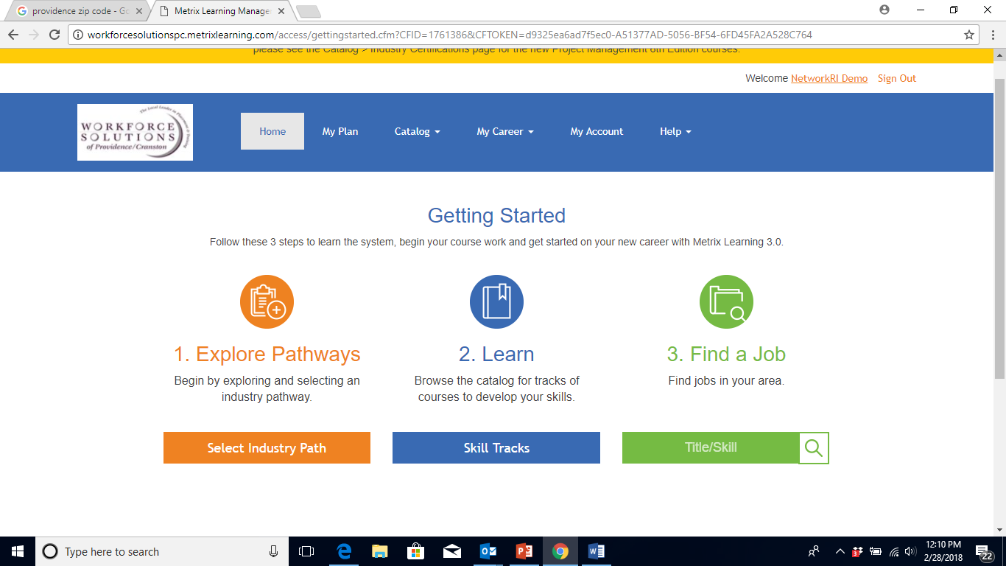

Four ‘Getting Started’ courses will be available for each customer in their ‘My Plan’.
These courses are not mandatory.

